

V 1.0
March 2026
Functional & Technical XStep Specification
SMPL: Culture Weight

Table of Contents
Functional Requirements 3
1 Purpose 3
2 Overview 3
3 Reasons for developing 4
4 Authorization 4
5 Assumptions/ Dependencies 5
6 Security Objects 5
7 Development Type 5
8 Processing Options 5
9 Functional Mapping Rules for Fields 6
10 Validation Checks 6
General Technical Specification 7
11 Technical XStep Layout Design 7
12 XStep Technical Specification 7
12.1 Parameters: 7
12.2 Development Architecture 11
12.3 Parameter Configuration 12
12.4 Technical Implementation 13
13 Function Module(s) 14
14 Pseudocode 15
15 Configuration Specifications 19
16 Test Scenarios 19
17 Document References 22
18 Revision History 22

Functional Requirements

Purpose
This document outlines the functional and technical design, along with the configuration specifications for the XStep “SMPL: Culture Weight”.

Overview
The SMPL: Culture Weight XStep allows operators to enter the average cell density into the entry field. The weight of culture to add along with the tolerances and number of flasks needed will populate based on the value entered.
Functional Design
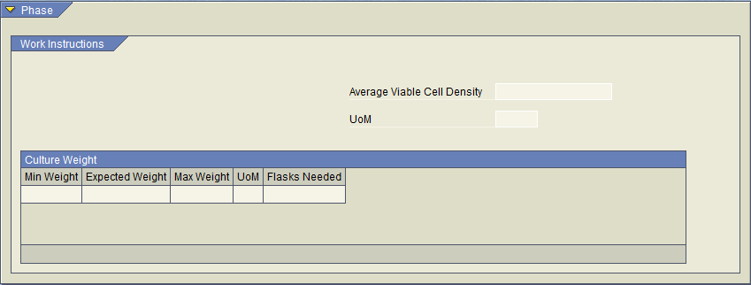

The Average Viable Cell Density entry field will trigger a function call when a value is entered. The function will parse the ZTC_CULTURE_WEIGHT z-table or the correct Cell Density range and return the Min Weight, Max Weight, Expected weight, UoM and Flasks needed field as specified in the table.

If a value is entered that is outside the available options within the table then a validation popup will occur.

The UoM Field below the Average Viable cell Density will be defaulted to “10^6 cells/mL”

The Entry field will be changeable until the process step is completed though the performed by signature. If the value for average viable cell density changes then the table values will also update to the correct values from the z-table.

Z-Table Design

Z-table ZTC_CULTURE_WGHT will be created with the following fields.

- MANDT - MANDT
- DENSITY_LOW - QUAN - Length 13, Decimal 3
- DENSITY_HIGH - QUAN - Length 13 Decimal 3
- WEIGHT - QUAN - Length 13 Decimal 3
- FLASKS - CHAR - Length 30

The z-table will contain the relevant information from the screenshot below, that will be configurable through a dataload transaction.

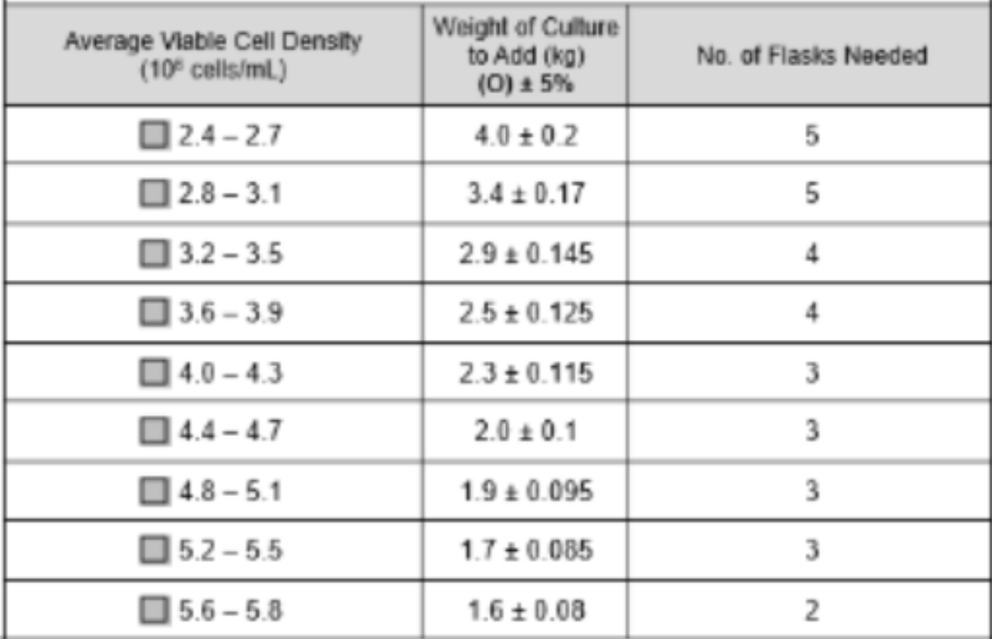

Reasons for developing
The SMPL: Culture Weight XStep was developed to allow the operator to determine the weight of culture to add based on the average viable cell density.

Authorization
N/A

Assumptions/ Dependencies
 | Assumption
1 | Master Data has been set up correctly
2 | The function module is available and returns weight and number of flasks based on field entry
3 | The function module can successfully pull the data into the output fields

Security Objects
Object Name | Description
Signature validation | Optional

Development Type
Development Type: |  | Report |  | Interface |  | Conversion |  | Enhancement
 |  | Form |  | Workflow |  | Portal |  | EDI
 |  | Screen |  | Data Cleansing |  | Data Dependencies
 | X | Other: | XStep

Processing Options
Processing Options
Processing Mode: |  | Batch | X | Online
Frequency |  | Annually |  | Quarterly |  | Monthly |  | Weekly
 |  | Daily |  | Minutes
 | X | Other: | Executed per EBR

Functional Mapping Rules for Fields
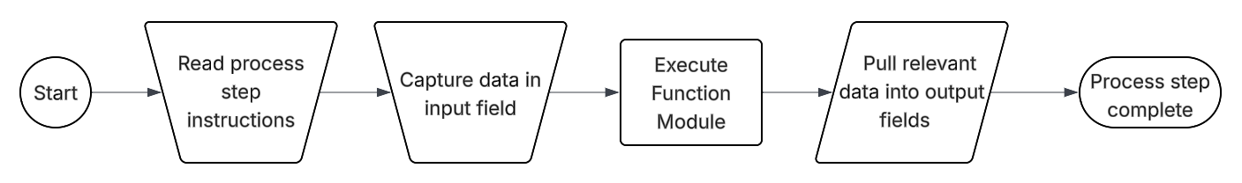

Validation Checks
Error Handling
Error | Action
Average Cell density entered does not match a value configured in the FM. | Raise a validation error that Entered Cell Density is outside the preconfigured range.

General Technical Specification

Technical XStep Layout Design
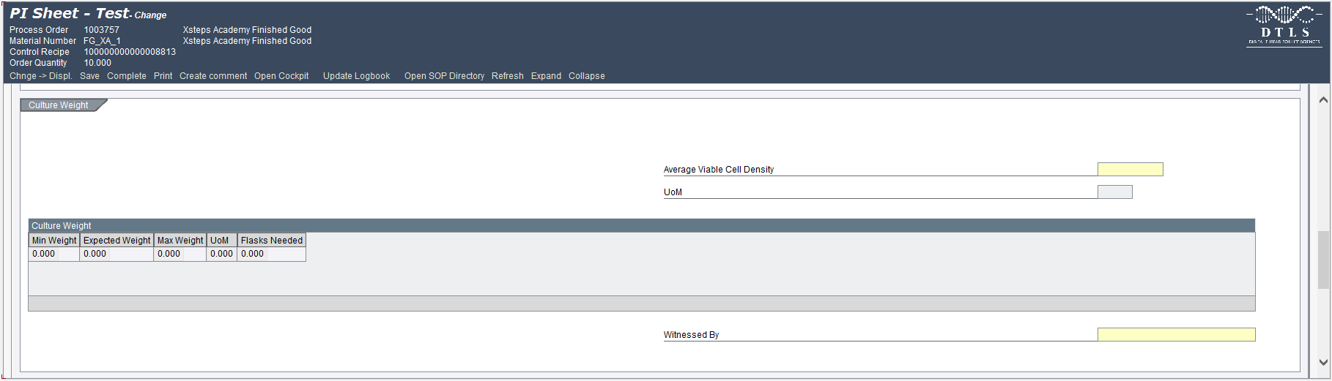

XStep Technical Specification

12.1 Parameters:
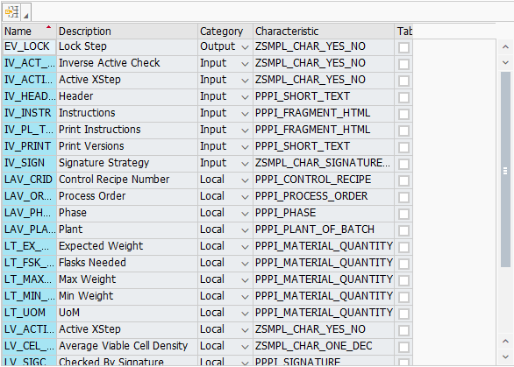
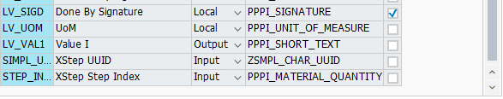

12.2 Development Architecture
The SMPL: Culture Weight XStep is developed to facilitate the determination of the culture weight and number of flasks. Operators are guided to input the average viable cell density which pulls in the correct values through a preconfigured function call. Manual entry is supported but controlled, enabling real-time adjustments while preserving traceability. A signature step at the end of the XStep ensures proper authorization and compliance with manufacturing standards.

12.3 Parameter Configuration
This XStep includes input and local parameters to manage content display, input validation, and enter the average viable cell density.
Configuration Parameters
- IV_HEADER (PPPI_SHORT_TEXT) – Configurable header text displayed at the top of the XStep via the SiMPL MBR
- IV_INSTR (PPPI_FRAGMENT_HTML) – Instructional content for operators, displayed under the header
- IV_ACTIVE / IV_ACT_FLP (ZSMPL_CHAR_YES_NO) – Controls whether the step is active and visible in execution
- IV_SIGN (ZSMPL_CHAR_SIGNATURE_STRAT) – Signature strategy to authorize and finalize equipment assignment
- IV_PRINT / IV_PL_TXT (PPPI_SHORT_TEXT / PPPI_FRAGMENT_HTML) – Controls print version and instruction print configuration
- IV_TITLE1 (PPPI_SHORT_TEXT) – Optional title for secondary display context
- IV_VERIFY (ZSMPL_CHAR_SIGNATURE_STRAT) – Optional verification signature strategy
- SIMPL_UUID (ZSMPL_CHAR_UUID) – Unique XStep identifier for traceability
- STEP_INDEX (PPPI_MATERIAL_QUANTITY) – Indicates the XStep’s position in the execution sequence
Output and Local Parameters
- LAV_ORDER (PPPI_PROCESS_ORDER) – Auto-filled with process order number
- LAV_PHASE (PPPI_PHASE) – Displays the current process phase
- LAV_PLANT (PPPI_PLANT_OF_BATCH) – Displays the production plant
- LAV_CRID (PPPI_CONTROL_RECIPE) – Displays the control recipe number
XStep Dependency Configuration
The following fields are used to link the dependency configuration in SiMPL MBR to the XStep structure:
- LV_LOCK(ZSMPL_CHAR_YES_NO) – Locking parameter
- EV_LOCK(ZSMPL_CHAR_YES_NO) - Output parameter that indicates locking decision
These parameters work in conjunction with the /SMPL/MBR_DEP_CHECK_ACTIVE function module, which checks to see if the current XStep has any dependencies. If there are any active dependencies linked to the XStep, the XStep will either be locked, or execution will be prevented, until the dependent step has been completed.
No additional setup is required from the XStep itself regarding the parameters listed above. The solution is already included for each XStep, so only the MBR configuration is required on the master recipe level for dependency information, if any inter-dependencies are needed throughout the PI Sheet.

12.4 Technical Implementation
Function Button Integration
NA
Field Behavior and Flexibility
Average Viable Cell Density accepts numbers with a single decimal point. Once entered, this input triggers a function module to populate the culture weight table with Min Weight, Expected Weight, Max Weight, UoM, and Flasks Needed.
Signature Validation Mechanism
After the step is fully executed, operators are required to sign off using the configured signature strategy (IV_SIGN), confirming the assignment for audit and compliance purposes.
Applicability and Execution Control
- The IV_ACTIVE parameter determines whether the XStep is enabled during execution.
- The IV_ACT_FLP parameter ensures mutual exclusivity or alternate routing by acting as an inverse flag.
Data Integration and Traceability
- UUID-based tracking supports full traceability in the electronic batch record.
- Signature events are logged and auditable.

Function Module(s)
Function: Z_SMPL_FM_CULTURE_WEIGHT
Import Parameters:
Parameter Name | Associated Type | Short Text
IM_CELL_DENSITY | ERFMG | Average Cell Density

Export Parameters:
Parameter Name | Associated Type | Short Text
EX_TARGET | ERFMG | Target Culture Weight
EX_MIN | ERFMG | Min Culture Weight
EX_MAX | ERFMG | Max Culture Weight
EX_FLASK | ERFMG | Number of Flasks

Function: /SMPL/PPPI_FM_INITIAL_ACTIVE
Import Parameters:
Parameter Name | Associated Type | Short Text
IV_ACTIVE | CHAR1 | N/A

Export Parameters:
Parameter Name | Associated Type | Short Text
EV_ACTIVE | CHAR1 | N/A

Function: /SMPL/MBR_DEP_CHECK_ACTIVE
Import Parameters:
Parameter Name | Associated Type | Short Text
IM_CONTROL_RECIPE | POC_DOCID | N/A
IM_PHASE | VORNR
IM_AUFNR | AUFNR
IM_STEP_UUID | /SMPL/MBR_SOG_UUID
IM_PLANT | WERKS_D

Export Parameters:
Parameter Name | Associated Type | Short Text
EV_ACTIVE | CHAR1 | N/A

Exceptions:
Exception | Short Text
CONTROL_RECIPE_INITIAL

Pseudocode
Function: ZSMPL_FM_CULTURE_WEIGHT
1. Initialization
- The FM selects an entry from z-table ZTC_CULTURE_WEIGHT based on IM_CELL_DENSITY.
  - Z-table has two fields Densisty_low and Densisty_high to use for the selection criteria i.e. between 2.1 and 2.5
- The Expected weight value is returned along with the number of flasks value
- A calculation determines the min and max parameters by multiplying the Expected weight by 5% the adding or subtracting from the original weight to gain the min and max values.
  - 4.0*0.05 = 0.2 therefore 3.8 and 4.2 for Min and Max respectively
- Assign values to export parameters and return

Function: /SMPL/PPPI_FM_INITIAL_ACTIVE
1. Initialization
a. Input parameter IV_ACTIVE is optionally provided by the calling logic.
b. Constants gc_yes, gc_no, and gc_inside_range are assumed to be defined globally in the context of the function module.
2. Active Flag Evaluation
a. The function checks if the input value IV_ACTIVE falls within the expected valid range, represented by gc_inside_range.
b. Based on the result:
- If the input value is not equal to gc_inside_range, the XStep is marked as inactive by setting EV_ACTIVE = gc_no.
- If the input value is equal to gc_inside_range, the XStep is marked as active by setting EV_ACTIVE = gc_yes.
3. Output Assignment
a. The evaluated result is returned in the EV_ACTIVE export parameter for use by the calling logic (e.g., XStep configuration, PI sheet rendering).
Additional Notes
- This is a simple normalization function that abstracts how activation flags are interpreted for PPPI XSteps
- The use of constants (gc_yes, gc_no, and gc_inside_range) allows the logic to be aligned with broader application settings or standards.
- Helpful in scenarios where input values may vary but need to result in consistent "active" or "inactive" behavior.
- Input is optional, so defaulting behavior can be configured outside this function.
- This function improves clarity and consistency in determining whether an XStep should be active when rendered in the PI Sheet.

Function: /SMPL/MBR_DEP_CHECK_ACTIVE
1. Initialization
a. Input parameters provide context for determining whether an MBR (Manufacturing Batch Record) step can be activated:
- IM_CONTROL_RECIPE (POC_DOCID) – Control recipe ID identifying the batch instruction.
- IM_PHASE (VORNR) (Optional) – Operation or phase within the process order.
- IM_AUFNR (AUFNR) (Optional) – Process order number associated with the step.
- IM_STEP_UUID (/SMPL/MBR_SOG_UUID) – Unique step identifier (SOG).
- IM_PLANT (WERKS_D) – Plant code for process context.
b. The function first validates that IM_CONTROL_RECIPE is not initial.
- If it is initial, the exception CONTROL_RECIPE_INITIAL is raised.
c. Internal data is initialized:
- lt_ord_sigs: Internal table for storing order signature data from /SMPL/MBR_OR_SIG.
- ls_step_dep: Work area for step dependency data.
- Routine LOAD_INTERNAL_DATA is called to populate internal buffers (g_ord_data-t_ord_deps) using IM_AUFNR, IM_CONTROL_RECIPE, and IM_STEP_UUID.
2. Signature Data Retrieval
a. The function retrieves signature records for the process order from database table /SMPL/MBR_OR_SIG.
b. Selected fields include: AUFNR, SOG_UUID, TYPE, CREATED_DATE, CREATED_TIME, DEST_NAME, SIGN_ID, SIGN_DATE, and SIGN_TIME.
c. Only signatures related to the specified order (AUFNR = IM_AUFNR) are selected.
d. These records are stored in the internal table lt_ord_sigs for later evaluation.
3. Dependency Evaluation
a. The function loops through dependencies in g_ord_data-t_ord_deps where:
- TARGET_UUID = IM_STEP_UUID, and
- DEP_RULE is either gc_perform_before_start_rule or gc_verify_before_start_rule.
b. For each dependency record:
- If the rule is PERFORM BEFORE START, it checks whether the prerequisite step (PREREQ_UUID) has a pending perform signature (gc_perform_signature) with SIGN_ID = abap_false.
- If the rule is VERIFY BEFORE START, it checks whether the prerequisite step (PREREQ_UUID) has a pending verify signature (gc_verify_signature) with SIGN_ID = abap_false.
c. If an incomplete signature is found, the step is marked inactive (EV_ACTIVE = gc_step_inactive).
d. If all prerequisite signatures are complete, the step is marked active (EV_ACTIVE = gc_step_active).
4. Output Assignment
a. The evaluated activation status is returned in the export parameter EV_ACTIVE.
- gc_step_active – All prerequisite steps are completed; the current step can start.
- gc_step_inactive – At least one prerequisite step is incomplete; the current step remains blocked.
Additional Notes
This function determines whether a dependent step in a Manufacturing Batch Record is eligible to start based on the completion of prerequisite steps.
Key Features:
- Evaluates Perform Before Start and Verify Before Start dependency rules.
- Dynamically validates signature data from /SMPL/MBR_OR_SIG.
- Integrates with existing MBR dependency structures via global table g_ord_data-t_ord_deps.
Error Handling:
- Raises CONTROL_RECIPE_INITIAL if the control recipe input is missing.
- Handles empty dependency or signature data without runtime errors.
Dependencies:
- Tables: /SMPL/MBR_OR_SIG (Signatures), g_ord_data-t_ord_deps (Step Dependencies).
- Constants: gc_perform_before_start_rule, gc_verify_before_start_rule, gc_perform_signature, gc_verify_signature, gc_step_active, gc_step_inactive.
- Routine: LOAD_INTERNAL_DATA for initializing order context.
Assumptions:
- All prerequisite steps are recorded in the dependency table.
- Signature records are current and synchronized with MBR step progression.
Activation status is recalculated each time the function is called to reflect live signature data.

Configuration Specifications
N/A

Test Scenarios
Variant 1: Equipment Select
# | Scenario | Expected Result | Actual Result | Pass/ Fail
1 | Create and Release a Process Order with the pre-configured SiMPL Master Recipe and the relevant Production Version | Process Order created and Released containing SMPL: Culture Weight
2 | Open the EBR and navigate to Phase 0030 and then navigate to SMPL: Culture Weight | The EBR for the selected Process Order and Control Recipe opens successfully without any errors and the SMPL: Culture Weight step is visible in Phase 0030
3 | Enter Average Viable Cell Density that is outside the configured range. | Validation is triggered
4 | Discard Validation popup | Validation popup is closed
5 | Enter Average Viable Cell Density that is within the configured range | Value accepted, Output Parameters in Cell Culture Table are updated
6 | Change Average Viable Cell Density to another value that is in a different segment of the configured range. | Value accepted, Output Parameters in Cell Culture Table are updated
7 | Change Average Viable Cell Density to another value that is in the same segment of the configured range. | Value accepted, Output Parameters in Cell Culture Table remain the same.

Document References
Reference No. | Document Title
Number used in superscript for reference | Full name of referenced document
1 | SiMPL Functional Guide: Universal Concepts

Revision History
Version No. | Description | Author | Date
1 | Initial Functional Design Information | Thomas Rautenbach | 31MAR2026
1.1 | Technical Design Information | Dennis Kim | 27APR2026

